 **TIJUANA INSTITUTE OF TECHNOLOGY**

**ACADEMIC**

**DEPARTMENT OF SYSTEMS AND COMPUTATION COMPUTER**

**SYSTEMS ENGINEERING**

**SEMESTER**

FEBRUARY- JULY 2022

**SUBJECT**

BDD-1703SC9C Data Mining

**Activity**

Practice 3

**Teacher**

MC JOSE CHRISTIAN ROMERO HERNANDEZ

**Student**

17212327 -Aldarete Delgado Angel Esteban

17210659 - Villegas Carmona Damaris

Instructions

Analyze the code corresponding to the data visualization of the logistic regression machine learning model.

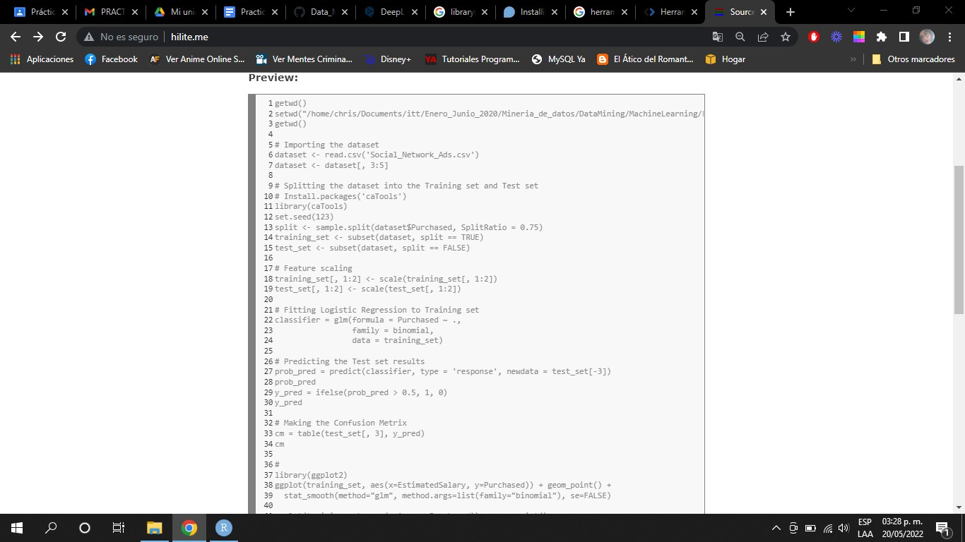

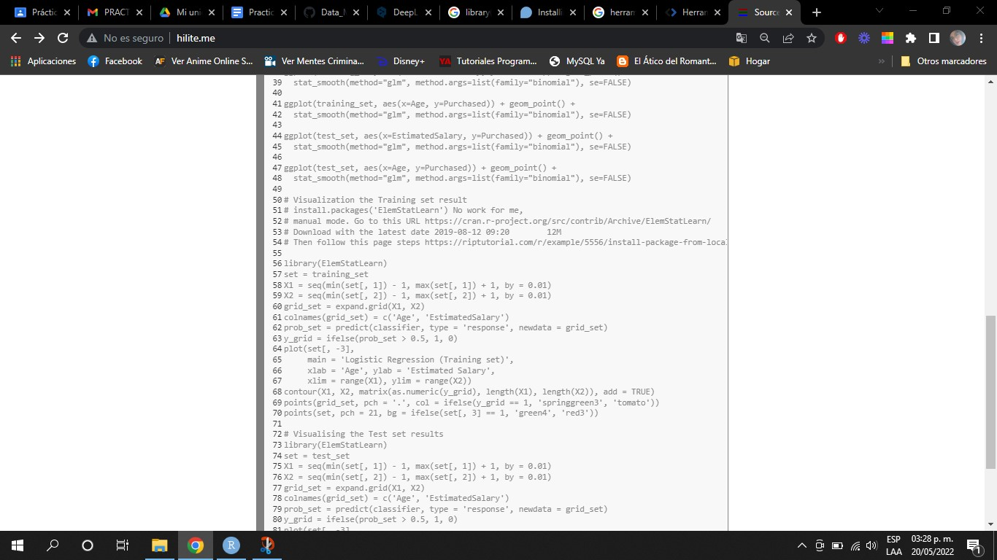

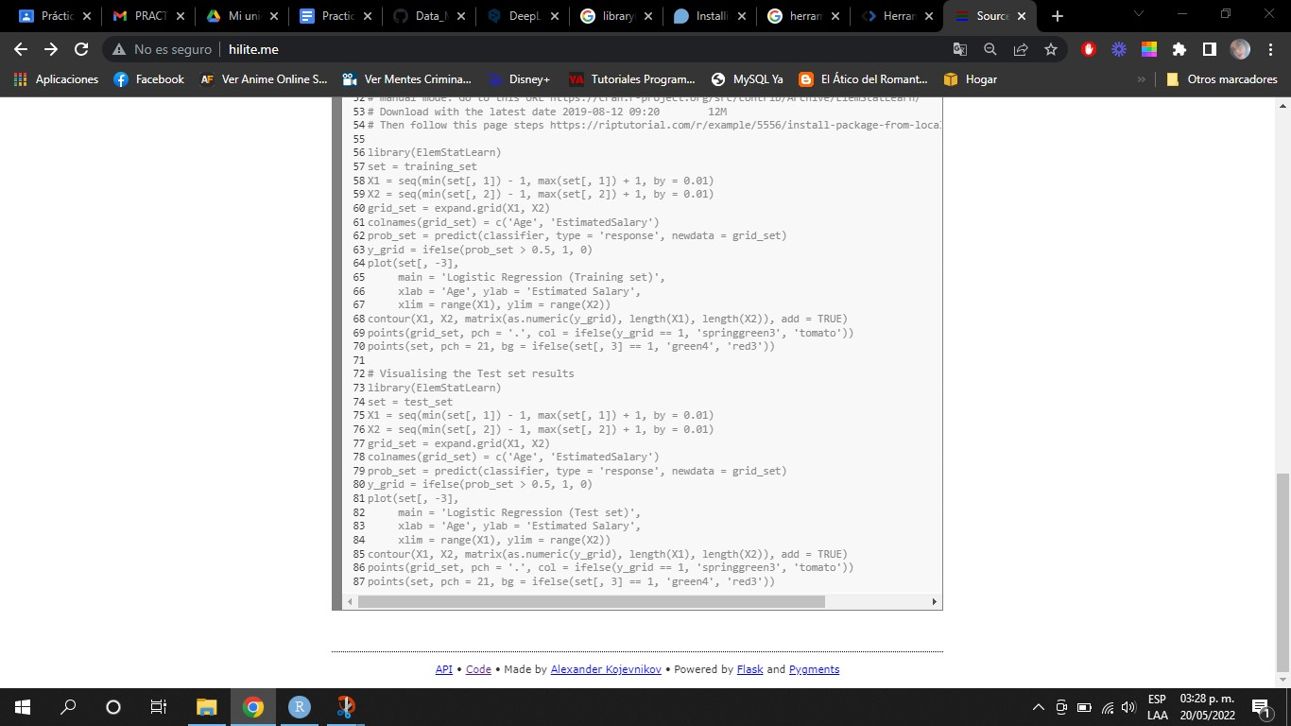

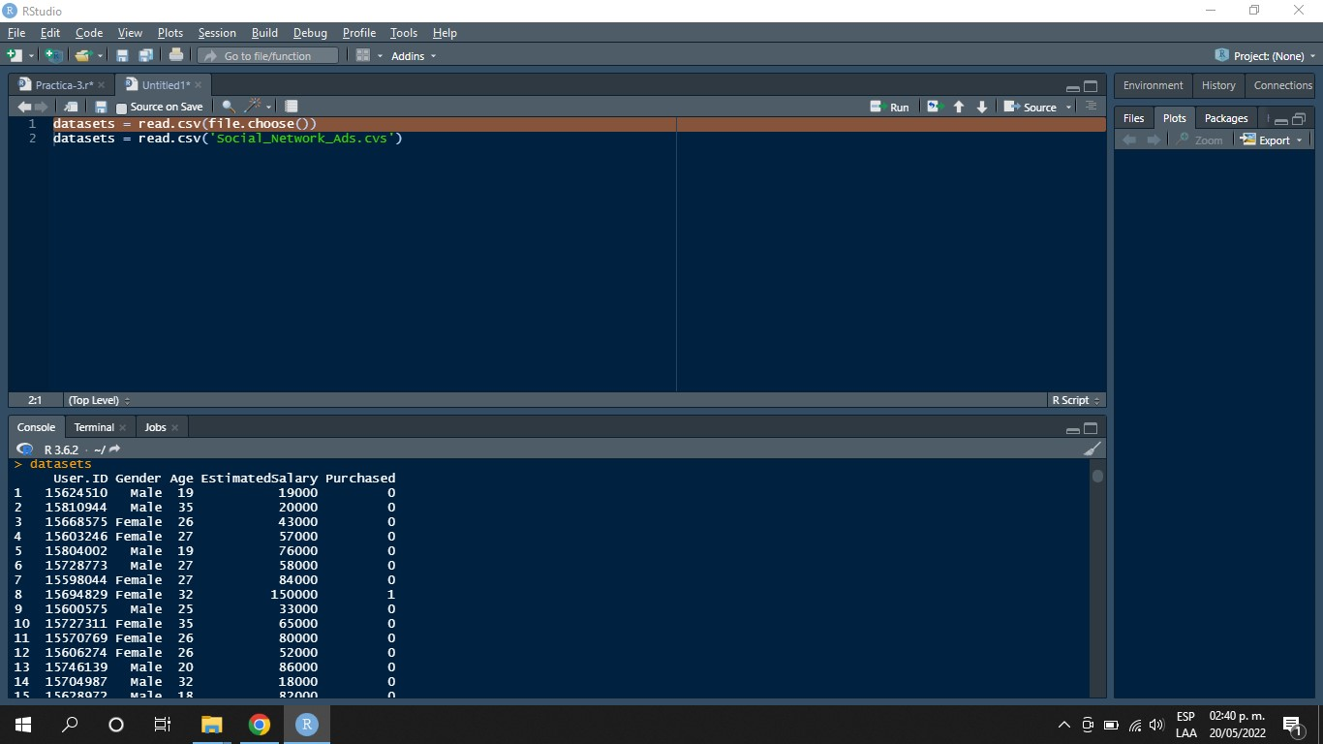

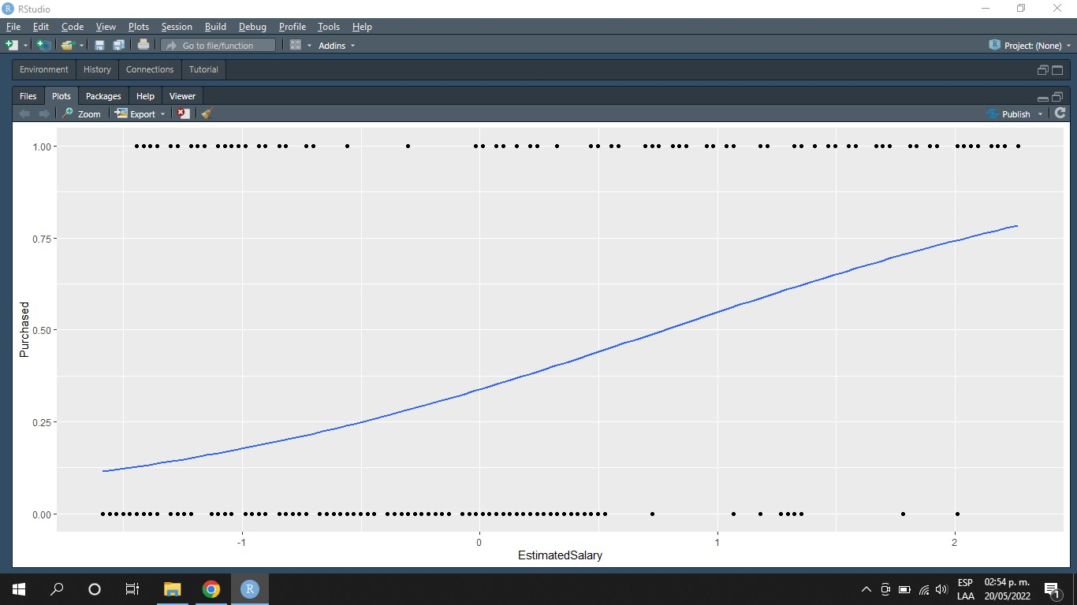

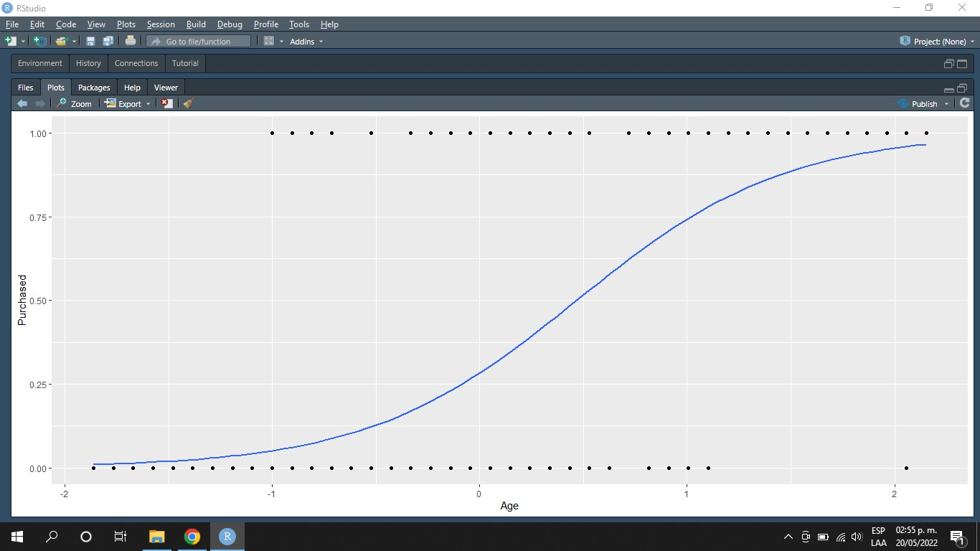

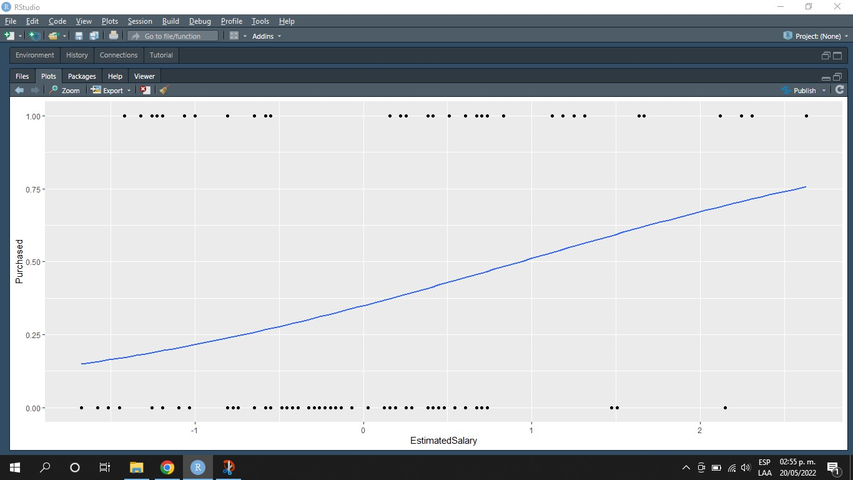

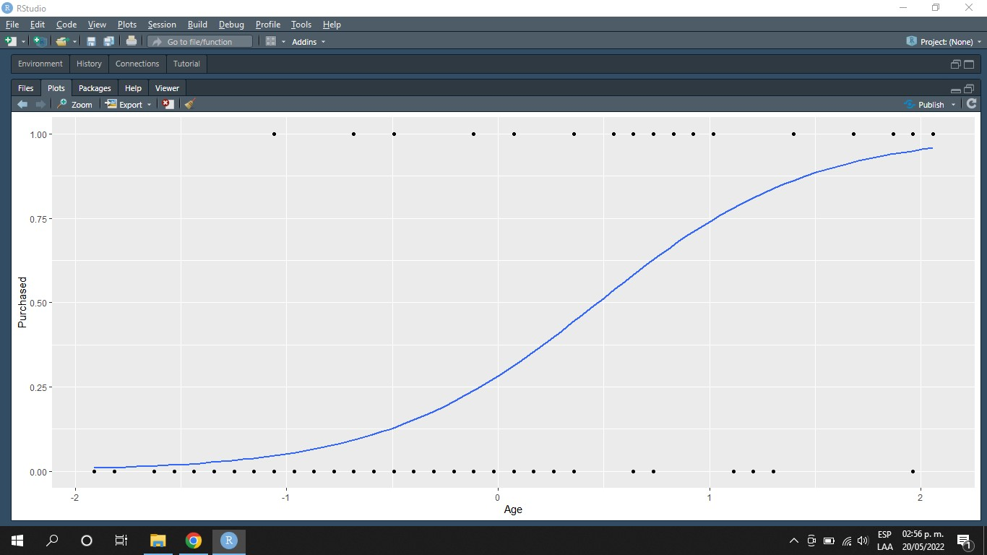

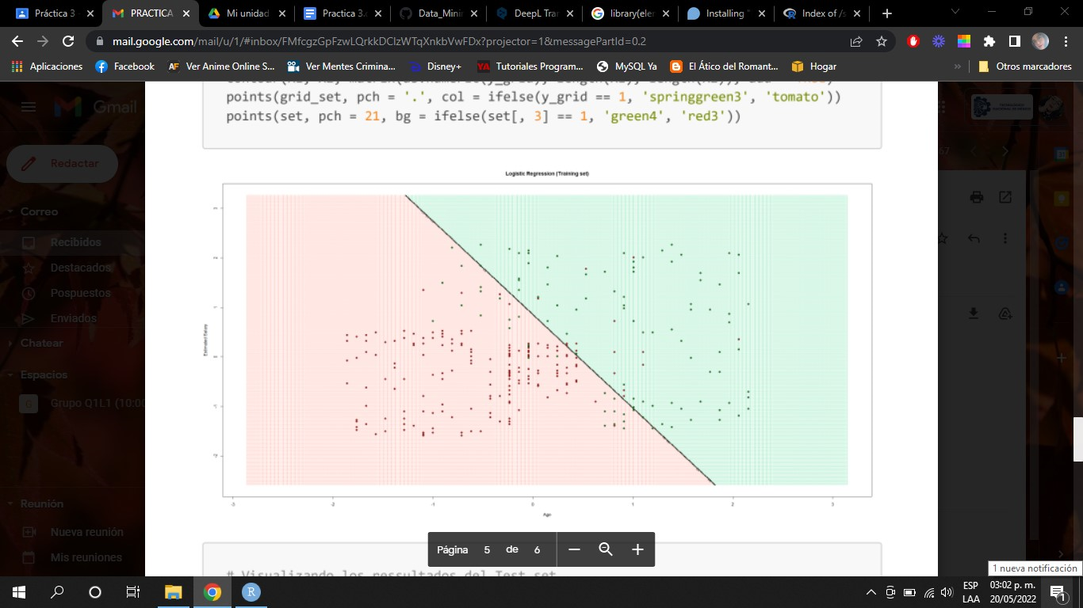

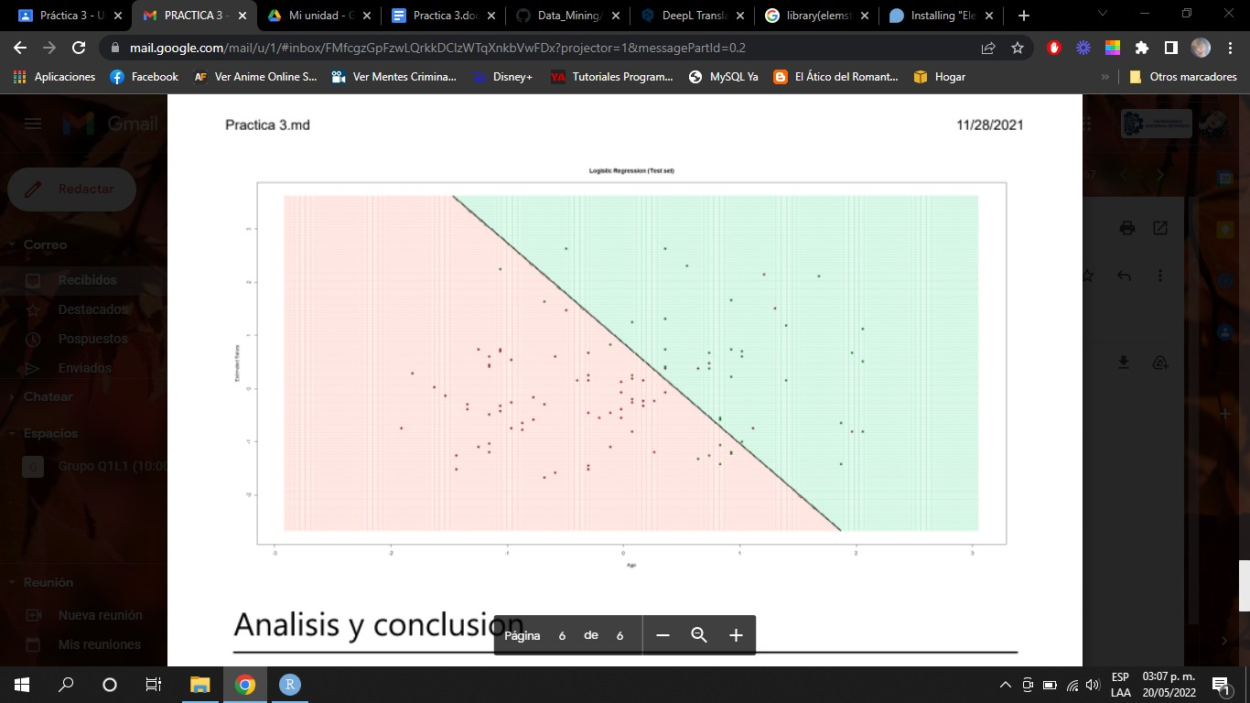

Conclusions:

Once we started running the program we could see that it was possible to detonate the linear regression and with this we could verify what was explained in class.